Project Design Phase-II

Data Flow Diagram & User Stories

|  |  |
| --- | --- |
| Team ID | 88A47BC9080CDE499E844AF1A08CEE03 |
| Project Name | Creating an sponsored post for Instagram |

**Data Flow Diagrams:**

A Data Flow Diagram (DFD) is a traditional visual representation of the information flows within a system. A neat and clear DFD can depict the right amount of the system requirement graphically. It shows how data enters and leaves the system, what changes the information, and where data is

stored.

**Example:** [**(Simplified)**](https://developer.ibm.com/patterns/visualize-unstructured-text/)

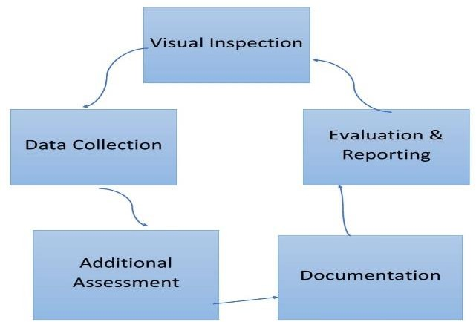

Example: Data Flow Diagram

Post content is sent for review

User Profile Data

Sponsored Post Content

Instagram User, Advertiser

User Authentication and Post Creation , Post Publishing

Data Flows

Data stores

Processes

External Entities

|  |  |  |  |  |  |  |
| --- | --- | --- | --- | --- | --- | --- |
| **User Type** | **Functional Requirement (Epic)** | **User Story Number** | **User Story / Task** | **Acceptance criteria** | **Priority** | **Team Member** |
| Content Creators | User Registration & profiles | USN-1 | As a user I Click the "Sign Up" button on the platform's homepage and fill in your full name, email, and a secure password. | I can Ensure that the user registration process collects essential information such as name, email, and password. | High | Suruthi |
|  |  | USN-2 | As a user I Confirm that you receive and click the verification link in the email sent to you for email confirmation.. | I can Implement email verification to confirm the authenticity of registered users | High | Sowmiya |
|  |  | USN-3 | As a user, I Log in using your registered email and password to access the platform's collaboration tools for sponsored content creation using canva. | I can Enable users to provide optional profile details, like profile picture and a brief bio | Medium | Sneha |
|  |  | USN-4 | As a city residient,I Enhance your user profile with additional information to get started with creating and collaborating on engaging sponsored Instagram posts.. | Verify that registered users can successfully create and manage sponsored posts for Instagram within the project's interface | Medium | Sathiyapriya |
|  | Content creation & collaboration | USN-5 | Influencers and brands can collaborate on sponsored posts, including negotiation and agreement functionalities | I can create Content creation tools must allow for easy image and caption creation, with seamless collaboration options among team members | High | Suruthi |
|  | Sponsored post creation | USN-6 | As a user ,I should be able to create, customize, and schedule sponsored posts with captions, images, and tags. | Sponsored post creation should offer customization options for visuals and captions, ensuring alignment with brand guidelines. | High | Sowmiya |
| Social media Manager | Advertising | USN-7 | As a social media manager, I aim to craft an Instagram sponsored post to boost our project's visibility and engagement among our target audience. This post will feature captivating visuals and a persuasive caption in alignment with our project's goals and brand identity. | Advertisements within the project must target the intended audience demographics and interests effectively. | Low | Sneha |
|  |  | USN-8 | As a user I Create an Instagram sponsored post for our project to enhance audience reach and engagement, aligning with our project's identity and goals. | The project should provide detailed analytics to assess the performance and ROI of sponsored Instagram posts, enabling data-driven decision-making | Medium | Sathiyapriya |
| Digital Marketer | User Registration | USN-9 | As a user I Click the "Sign Up" button on the platform's homepage and fill in your full name, email, and a secure password. | I can Ensure that the user registration process collects essential information such as name, email, and password. | Low | Suruthi |
|  | Sponsored post creation | USN-10 | As a user ,I should be able to create, customize, and schedule sponsored posts with captions, images, and tags | Sponsored post creation should offer customization options for visuals and captions, ensuring alignment with brand guidelines. | High | Sowmiya |
| Administrator | Maintenance | USN-11 | As a administrator I can maintain all the activities of the website. | Administrator must maintain all activities of both the all performance. | Medium | Sneha |